1. Let’s see at the background of how OS runs before looking at the container.
2. Just Overview of OS.
   1. Most Operating System has kernel.
   2. This kernel is a running software process that governs access b/w all the programs that are running on our computer and all the physical hardware that is connected to your computer.
   3. 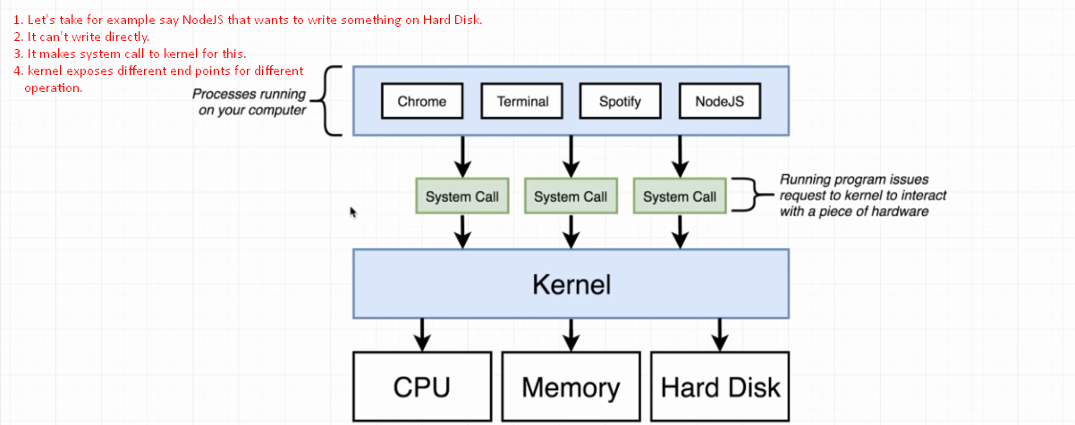  
      Thinking about this entire system (above snapshot), let’s pose a kind of hypothetical situation.  
      Let’s say we have two programs running on our Computer 🡺 Chrome and NodeJS.  
      Let’s now say Chrome needs Python2 installed on our system and NodeJS needs Python3 on our system.  
      But on our system, PythonV2 is called and we’re not allowed two identical installations of Python at the same time.  
      Chrome will work but NodeJS.  
      Well, how to solve this issue?  
      **🡺 One way** is by using Operation System’s feature called **name spacing**.